Project report on
Controlling Actuators using Web Server

Submitted by: The Embedded Elites

Group Members:
- Anirudh pal BT22ECI061
- Himanshu raj BT22ECI042
- Anurag Yadav BT22ECI047
- Neilrudra Mukherji BT22ECI034

A report submitted for the partial fulfillment of the requirements of the course
SENSORS AND TRANSDUSER (ECE 206)

Submission Date:20/11/2023

Under the guidance of:
Dr. Mayank Thacker

Department of Electronics and Communication Engineering



Table of Contents:

Chapter No. | Particular | Page No.
1 | Introduction | 2
2 | Code | 4
3 | Flow Chart | 7
4 | Connection Diagram | 8
5 | References | 9

PAGE 1

Chapter 1: Introduction

Remote computing plays an important role in many fields, such as transportation, robotics, and research. GPS (Global Positioning System) modules are widely used for outdoor telemetry, but can be inaccurate in urban areas due to signal interception and interference Piezoelectric sensors are another sensor that can be used for telemetry, but more frequently is not as accurate as the GPS modules.

The aim of this project is to develop an accurate and robust telemetry system by integrating a GPS module with a piezoelectric sensor. A piezoelectric sensor will be used to measure distance traveled over short distances, while a GPS module will be used to provide complete position information The system will be implemented using an Arduino microcontroller.

^{[1]}NEO-6M GPS Module

The NEO-6M GPS module is a robust GPS receiver featuring a built -in ceramic antenna measuring 25 x 25 x 4mm, enhancing its satellite search capabilities. The power and signal indicators provide real-time module status monitoring.

Features:

- 5Hz position update rate
- EEPROM to save configuration settings
- Rechargeable battery for Backup
- Support SBAS (WAAS, EGNOS, MSAS, GAGAN)

- Separated 18X18mm GPS antenna
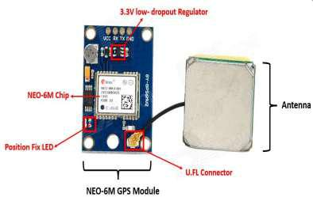

^{[5]}Figure 1. NEO-6M GPS Module

PAGE 2
^{[2]}SOUND SENSOR
The sound sensor is one type of module used to notice the sound. Generally, this module is used to detect the intensity of sound. The applications of this module mainly include switch, security, as well as monitoring. The accuracy of this sensor can be changed for the ease of usage.
This sensor employs a microphone to provide input to buffer, peak detector and an amplifier. This sensor notices a sound, & processes an o/p voltage signal to a microcontroller. After that, it executes required processing.
This sensor is capable to determine noise levels within DB’s or decibels at 3 kHz 6 kHz frequencies approximately wherever the human ear is sensitive. In smartphones, there is an android application namely decibel meter used to measure the sound level.

Sound Sensor Pin Configuration
This sensor includes three pins which include the following.
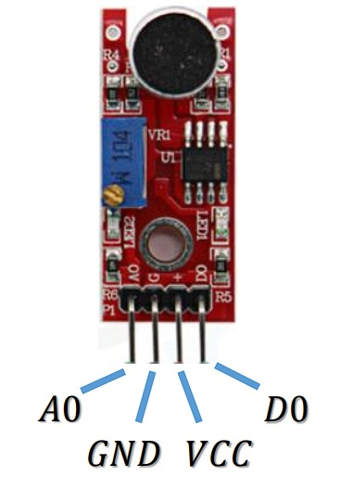sound-sensor-module
- Pin1 (VCC): 3.3V DC to 5V DC
- Pin2 (GND): This is aground pin
- Pin3 (DO): This is an output pin
- Pin4(AO): This is an output pin

PAGE 3

^{[3]}GAS SENSOR

MQ4 methane gas sensor is a MOS (metal oxide semiconductor) type sensor, used to detect the methane gas concentration within the air at either home or industries & generates output like analog voltage by reading it. Here, the range of concentration for sensing ranges from 300 pm – 10,000 ppm which is appropriate for the detection of a leak.
This gas sensor mainly includes a detecting element like ceramic based on aluminum-oxide (Al₂O₃), coated with Tin dioxide (SnO2) and arranged within a stainless-steel mesh.
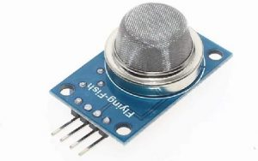MQ4 Gas Sensor
When methane gas and detecting elements get in contact with each other then the resistivity of the detecting element will be changed. After that, the change is measured to get the methane gas concentration. The ignition of Methane gas is extremely exothermal which means it generates a huge amount of heat once ignited.

PAGE 4

[4]
Chapter 2: CODE
#include <WiFi.h>
#include <WiFiAP.h>
#include <WiFiClient.h>
#include <WiFiGeneric.h>
#include <WiFiMulti.h>
#include <WiFiSTA.h>
#include <WiFiScan.h>
#include <WiFiServer.h>
#include <WiFiType.h>
#include <WiFiUdp.h>

#include <Wire.h>
#include <TinyGPS++.h>
#include <Adafruit_MQTT.h>
#include <Adafruit_MQTT_Client.h>

#define GAS_SENSOR_PIN 32
#define BUZZER_PIN 2
#define TOUCH_SENSOR_PIN 33 // Pin to which the touch sensor is connected

TinyGPSPlus gps;

bool gasDetected = false;
#define WLAN_SSID "realme"
#define WLAN_PASS "7549903908"
// Adafruit IO Setup
#define AIO_SERVER "io.adafruit.com"
#define AIO_SERVERPORT 1883
#define AIO_USERNAME "himanshuraz"
#define AIO_KEY "aio_xnvn44s1xfu2L4QH8hm89Cvbnd8p"

WiFiClient client;
Adafruit_MQTT_Client mqtt(&client, AIO_SERVER, AIO_SERVERPORT, AIO_USERNAME, AIO_KEY);

// Adafruit IO Feeds
Adafruit_MQTT_Publish gasFeed = Adafruit_MQTT_Publish(&mqtt, AIO_USERNAME "/feeds/gas");
Adafruit_MQTT_Publish touchFeed = Adafruit_MQTT_Publish(&mqtt, AIO_USERNAME "/feeds/piezor");
void MQTT_connect();

void setup() {
Serial.begin(115200);
pinMode(GAS_SENSOR_PIN, INPUT);
pinMode(BUZZER_PIN, OUTPUT);
pinMode(TOUCH_SENSOR_PIN, INPUT);
Serial.println(); Serial.println();
Serial.print("Connecting to ");
Serial.println(WLAN_SSID);

WiFi.begin(WLAN_SSID, WLAN_PASS);
while (WiFi.status() != WL_CONNECTED) {
delay(500);
Serial.print(".");
}
Serial.println();

Serial.println("WiFi connected");
Serial.println("IP address: "); Serial.println(WiFi.localIP());
}

void loop() {
// Read gas sensor value
MQTT_connect();
int gasValue = analogRead(GAS_SENSOR_PIN);
publishGasValue(gasValue);
int touchValue = analogRead(TOUCH_SENSOR_PIN);
// Publish touch sensor value to Adafruit IO
publishTouchValue(touchValue);
if(gasValue>1400){
buzzerAlert();
}

delay(10000);
// Maintain MQTT connection to Adafruit IO
// if (!mqtt.connected()) {
// connectToAdafruitIO();
// }
// mqtt.processPackets(100);
// mqtt.ping();
}

void buzzerAlert() {
digitalWrite(BUZZER_PIN, HIGH); // Turn the buzzer on
delay(500); // Buzz for 1 seconds
digitalWrite(BUZZER_PIN, LOW); // Turn the buzzer off
}

bool readGPSLocation() {
while (Serial.available() > 0) {
if (gps.encode(Serial.read())) {
return true;
}
}
return false;
}

void printGPSLocation() {
Serial.print("Location: ");
if (gps.location.isValid()) {
Serial.print("Lat: ");
Serial.print(gps.location.lat(), 6);
Serial.print(", Long: ");
Serial.print(gps.location.lng(), 6);
} else {
Serial.print("Lat: 0 ");
Serial.print("Long: 0");
}
Serial.println();
}

void publishGasValue(int value) {
Serial.print("Publishing gas value to Adafruit IO: ");
Serial.println(value);
gasFeed.publish(value);
}

void publishTouchValue(int value) {
Serial.print("Publishing touch sensor value to Adafruit IO: ");
Serial.println(value);
touchFeed.publish(value);
}

void MQTT_connect() {
int8_t ret;

// Stop if already connected.
if (mqtt.connected()) {
return;
}

Serial.print("Connecting to MQTT... ");

uint8_t retries = 3;
while ((ret = mqtt.connect()) != 0) { // connect will return 0 for connected
Serial.println(mqtt.connectErrorString(ret));
Serial.println("Retrying MQTT connection in 5 seconds...");
mqtt.disconnect();
delay(5000); // wait 5 seconds
retries--;
if (retries == 0) {
// basically die and wait for WDT to reset me
while (1);
}
}
Serial.println("MQTT Connected!");
}

Chapter 3: Flow Chart
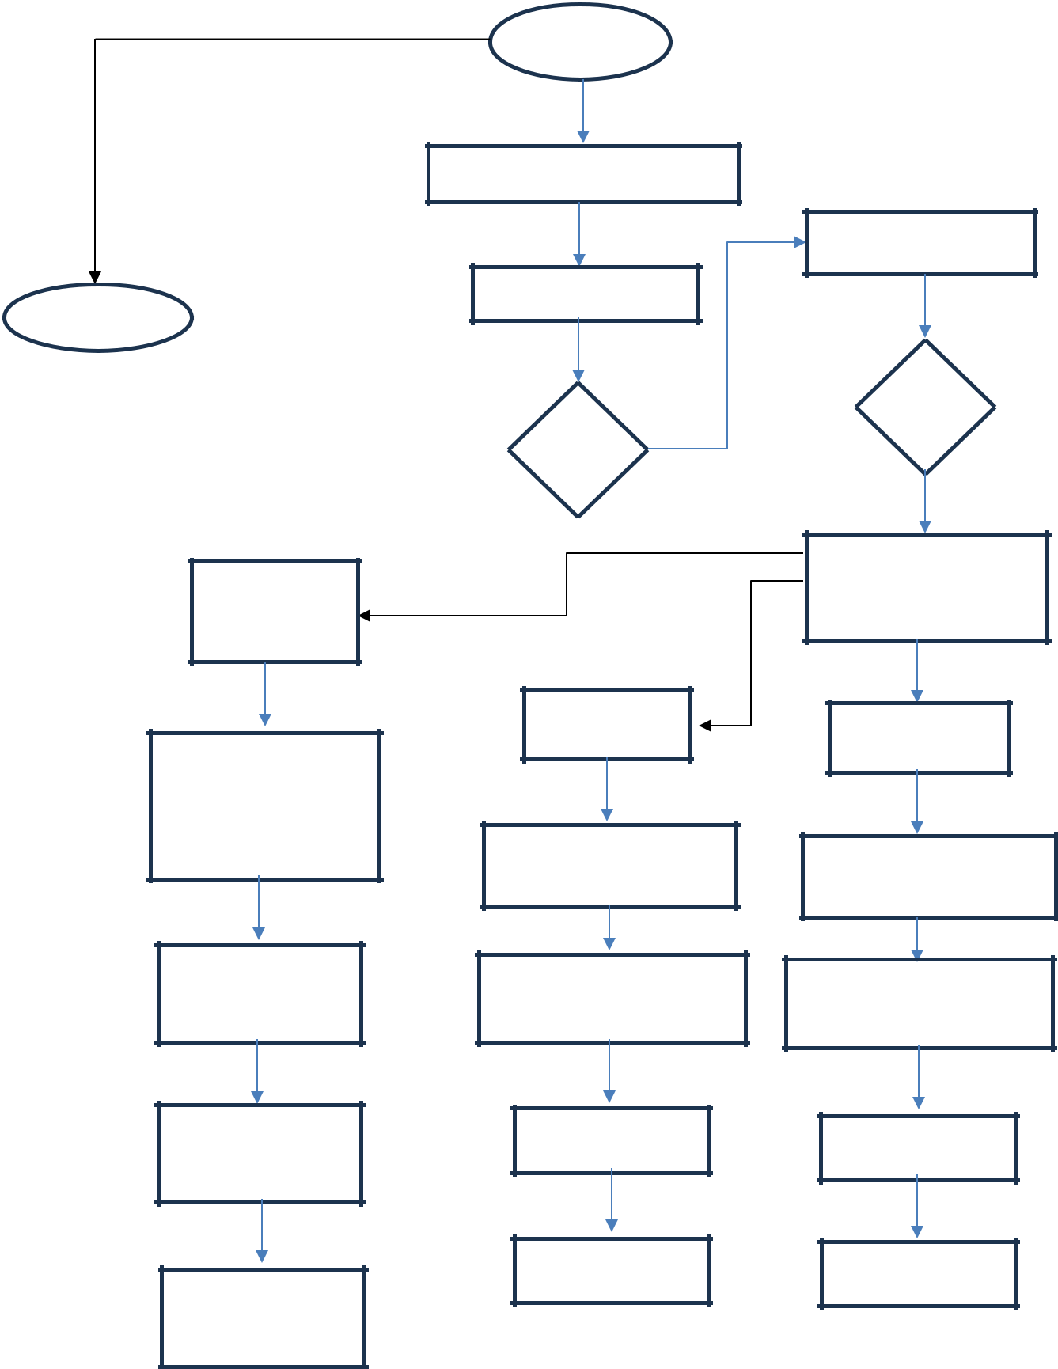

END

Else (both
positions are

recorded)

Calculate the distance between the two GPS positions using Haversine formula

Print the calculated

distance in meters

Reset ‘pos1’ and

‘pos2’ to false for

next readings

Delay for 2000
milliseconds

START

Initialize Serial Communication

Delay for 1 second

LOOP

Else, if ‘pos2’ is
false

Read GPS latitude and
longitude and store

them

Print latitude and

longitude for position 1

Set ‘pos2’ to true

Delay for 1000

milliseconds

Read analog data
V
from the sensor

CONDITION

reading is greater than

or equal to ‘knock’ Vi

threshold

If ‘pos1’ is false

Read GPS latitude and longitude and store them

Print latitude and longitude for position 1

Set ‘pos1’ to true

Delay for 1000

milliseconds

PAGE 7

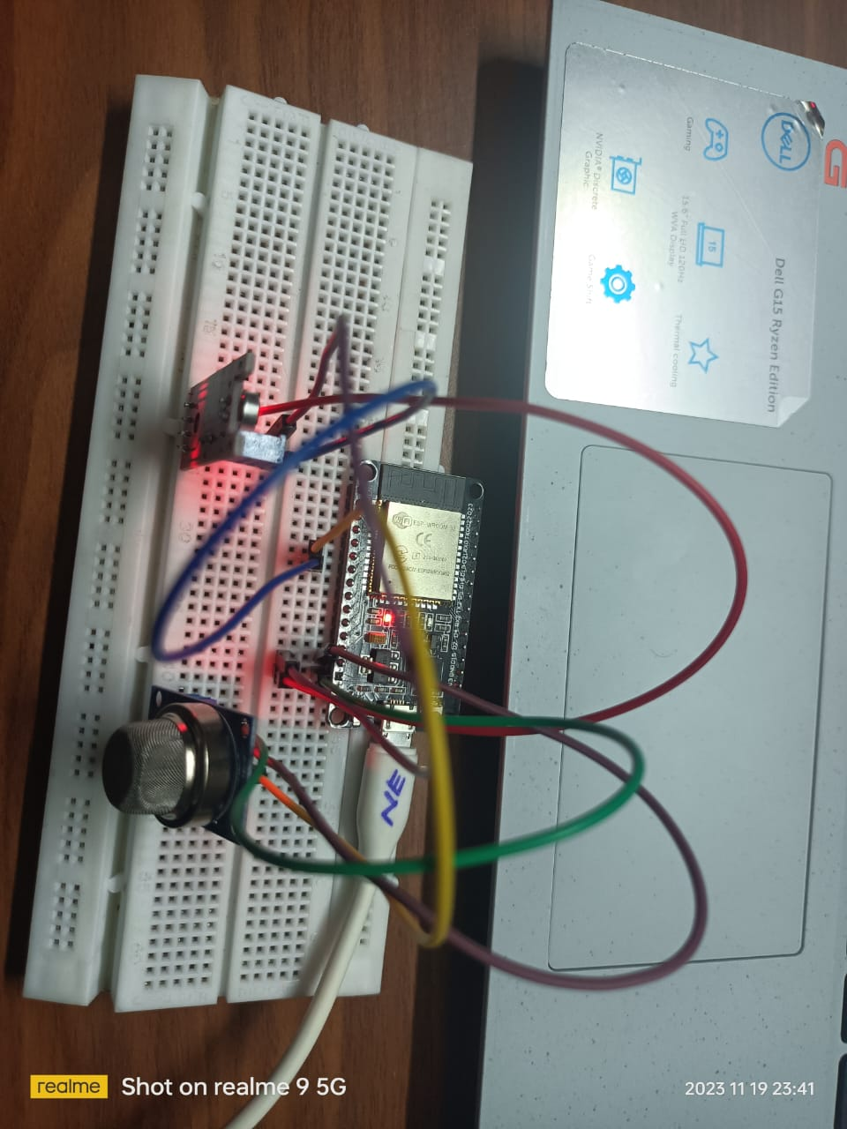Chapter 5: References

- https://wiki.sunfounder.cc/index.php?title=Ublox_NEO-6M_GPS_Module

- https://www.electronicpro.co.za/products/tzt-5v-piezoelectric-film-vibration-sensor-switch-module-ttl-level-output
- https://github.com/cifertech/Pocket-GPS

- https://www.elecbee.com/en-25152-3pcs-TZT-5V-Piezoelectric-Film-Vibration-Sensor-Switch-Module-TTL-Level-Output

- https://m.indiamart.com/proddetail/ublox-neo-6m-gps-module-19990293130.html

PAGE 9

